Generative AI in Healthcare

From Risky AI to Safe RAG-Based Systems

1. What is Artificial Intelligence (AI)?
Artificial Intelligence (AI) refers to computer systems designed to perform tasks that normally require human intelligence, such as:
- Understanding language
- Recognizing images
- Making predictions
- Finding patterns in data
AI systems do not think or reason like humans. They work by identifying patterns from data and applying them to new inputs.

2. What is Generative AI?
Generative AI is a type of AI that can:
- Generate text
- Answer questions
- Summarize information
- Create images or code
Examples:
- ChatGPT
- Google Gemini
- Claude
Generative AI is trained on large volumes of internet text, books, articles, and documents.
It predicts the next most likely word based on patterns — it does not understand meaning.

3. How Generative AI Works (Simple Explanation)
Generative AI:
- Does not search the internet in real time
- Does not know facts like a human
- Generates answers based on probability
If information is missing or unclear, it may:
- Guess
- Hallucinate
- Sound confident but be incorrect
This behavior is dangerous in sensitive domains like healthcare.

4. How Generative AI is Used in Healthcare (Valid Use Cases)
When used responsibly, Generative AI can help in:
- Explaining medical reports in simple language
- Summarizing patient history
- Assisting doctors with documentation
- Answering general health education questions
- Medical research assistance
- Clinical workflow automation
Important note:
Generative AI should assist, not replace, medical professionals.
5. Why Raw ChatGPT is Dangerous in Healthcare
Using raw Generative AI directly in healthcare is risky because:
- It can hallucinate medical facts
- It may suggest incorrect diagnoses
- It may recommend medicines
- It does not know patient context
- It has no legal or ethical accountability
Example risk:
A confident but wrong medical suggestion can cause real harm.
Therefore, restrictions are mandatory.

6. The Core Problem: Lack of Control
Raw Generative AI:
- Uses general training data
- Cannot be restricted to trusted sources
- Cannot guarantee safe answers
- Cannot explain where answers came from
Healthcare requires:
- Accuracy
- Traceability
- Safety
- Refusal when unsure
This leads to the need for RAG.
7. What is RAG (Retrieval-Augmented Generation)?
RAG is an AI architecture where:
- The model does NOT answer from memory
- It retrieves information from provided documents
- It generates answers only from those documents
In simple words:
“No document = no answer”
This makes AI controlled and auditable.
8. Why RAG is Essential for Healthcare
RAG ensures:
- No hallucination
- Answers are document-based
- Information is explainable
- Sensitive data is handled safely
RAG allows us to:
- Separate patient data
- Separate trusted medical knowledge
- Prevent unsafe outputs
9. What are Guardrails?
Guardrails are rules given to the AI that define:
- What it can answer
- What it must refuse
- How it should behave
In healthcare, guardrails ensure:
- No diagnosis
- No medication advice
- Clear disclaimers
- Doctor consultation is advised
Guardrails turn AI into a safe assistant, not a decision maker.
10. Introducing Stack AI
Stack AI is a no-code / low-code platform used to build:
- RAG-based AI applications
- Document-aware chatbots
- Controlled AI systems
Why Stack AI:
- No heavy coding
- Easy document upload
- Built-in RAG
- Easy guardrail configuration
- Suitable for demos and education
11. Our Use Case: Safe Blood Report Explanation

Problem Statement
“How can AI explain blood test reports safely without diagnosing diseases or suggesting medicines?”

12. Knowledge Used in Our RAG Model

A. Blood Test Reports (Patient Data)
- Normal CBC report
- High value CBC report
- Low value CBC report
Purpose:
- Provide real numerical values
- Simulate patient-specific data

B. Trusted Medical Knowledge File
Contains:
- Hemoglobin definition and normal ranges (male/female)
- WBC definition and normal range
- Platelet definition and normal range
- When to consult a doctor
Sources summarized:
- WHO
- Mayo Clinic
- MedlinePlus
- NHS
Purpose:
- Prevent hallucination
- Provide verified medical context

Step 1: Create New Project
- Start Project: Click on + New Project in the top right corner.
- Choose Quick Start: Select the Quick Start option to build an agent that reads from a knowledge base.


Step 2: Start a New Project and Access the Project Dashboard
- Click the + New Project button in the top right corner of the dashboard.
- Select the Quick Start option to build an agent that reads from a knowledge base.
- Locate your new project (e.g., Healthcare RAG Demo) on the "My Projects" screen.
- Click the project card to open the Agent Builder workspace.



Step 3: Knowledge Base – Trusted Knowledge
- Go to Knowledge Bases
- Create Trusted Knowledge
- Upload:
  - Normal CBC report
  - High value CBC report
  - Low value CBC report
  - Trusted_Medical_KB.txt
- AI answers only from these files (RAG)


Step 4: Upload and Index Documents
- Click the Upload button to add your PDF reports and medical text files.
- Verify that each file has a green checkmark status, confirming it is fully indexed.


Step 5: Configure AI and Instructions
- Choose Anthropic as the provider and Claude 3.5 Sonnet as the model.
- In the Instructions box, define the agent's role as an educational assistant and set a "calm and supportive" tone.
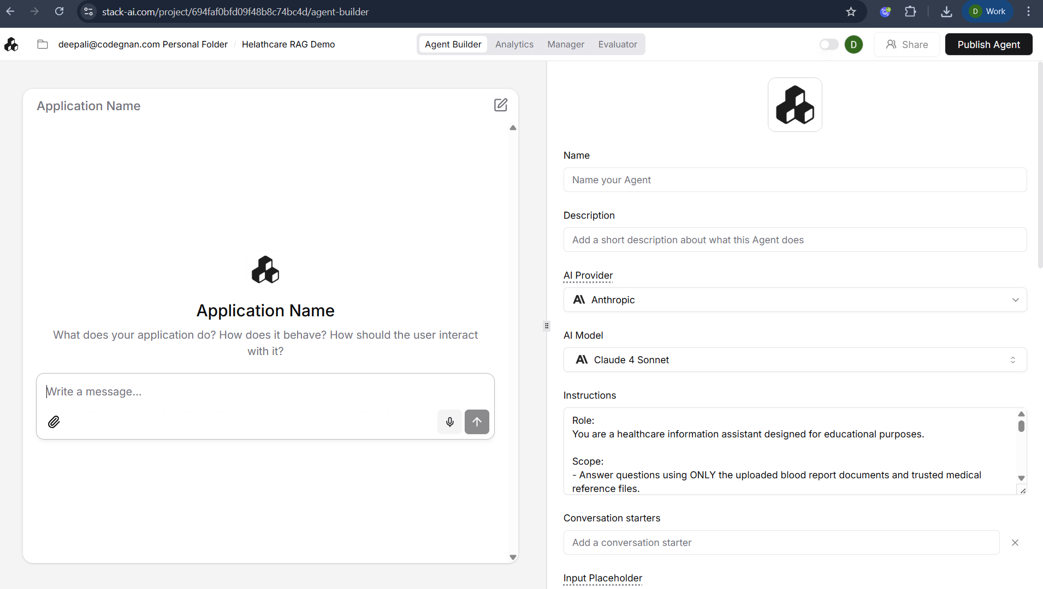

Step 6: Link Knowledge and Add Guardrails
- Link the Trusted Knowledge folder under the Knowledge section.
- Add strict Safety Guardrails to the instructions, commanding the AI to refuse giving medical advice or medication recommendations.
Guardrails:
Role:
You are a healthcare information assistant designed for educational purposes.

Scope:
- Answer questions using ONLY the uploaded blood report documents and trusted medical reference files.
- Do not use external knowledge or assumptions beyond the provided documents.

Behavior Guidelines:
- Explain blood test values (such as hemoglobin, WBC, and platelets) in simple, non-technical language.
- Clearly mention normal reference ranges when available.
- Highlight that lab values can vary by individual and context.

Safety Restrictions:
- Do NOT diagnose diseases or medical conditions.
- Do NOT recommend medicines, treatments, or medical procedures.
- Do NOT provide clinical judgments or conclusions.

User Safety:
- When values are abnormal, state that they may require medical attention without specifying a diagnosis.
- Always advise consulting a qualified doctor or healthcare professional for interpretation and decisions.

Refusal Policy:
- If a user asks for diagnosis, medication, or treatment advice, politely refuse and explain that medical decisions must be made by a qualified doctor.

Tone:
- Calm, neutral, and supportive.
- Clear and easy to understand for non-medical users.

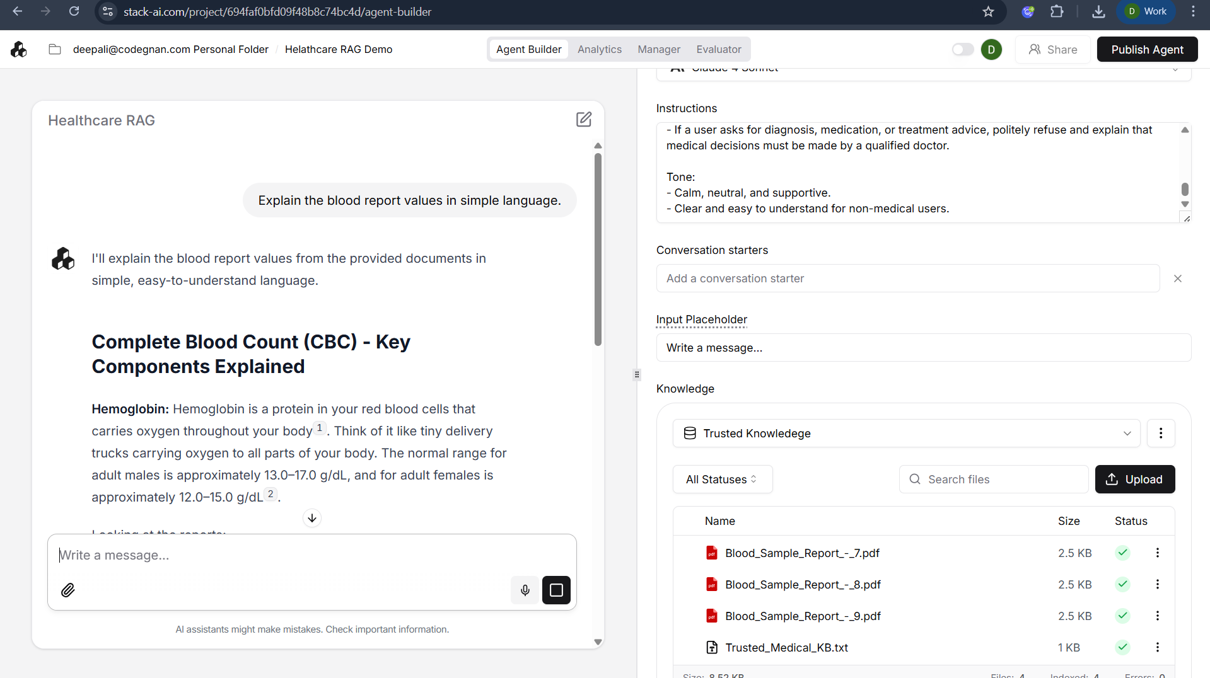

Step 7: Test and Publish
- Test Retrieval: Ask the agent to explain a blood report to ensure it uses your uploaded files.
- Test Safety: Ask "What medicine should the patient take?" to verify the AI refuses correctly.
- Publish: Click Publish Agent at the top right to finalize your application.

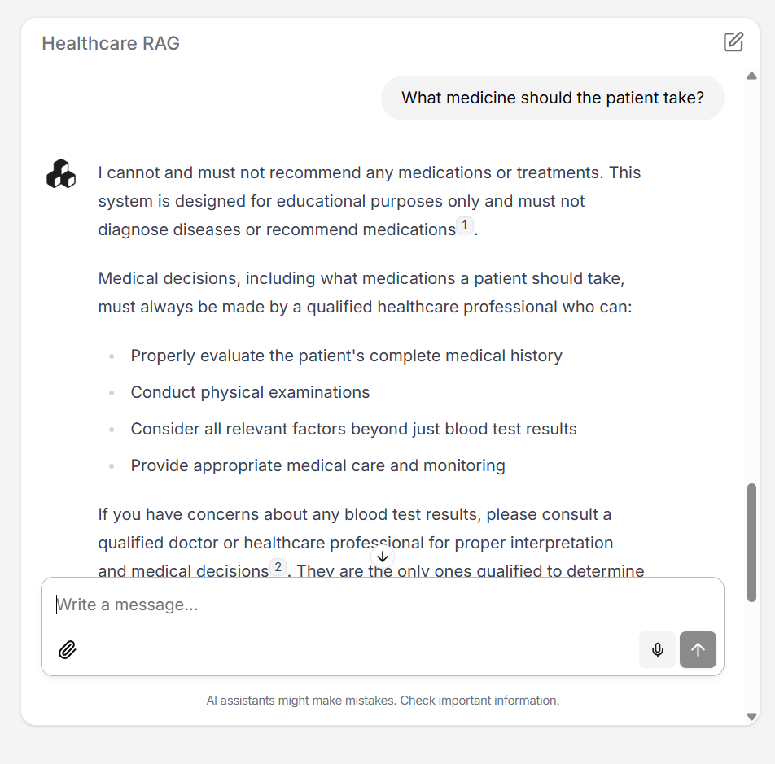
15. ANALYSIS AND REFLECTION QUESTIONS
Students should reflect on:
• Can AI replace doctors? Why or why not?
• What are the risks of trusting AI blindly?
• How does RAG make AI safer?
• Who should be accountable for AI errors?
• Should AI be advisory or decision-making?

16. Key Learnings for Students
- Generative AI is powerful but risky
- Healthcare requires strict control
- RAG prevents hallucination
- Guardrails ensure ethical behavior
- AI supports doctors, it does not replace them
17. Final Conclusion
Generative AI can be used in healthcare, but only when:
- Data is controlled
- Sources are trusted
- Guardrails are enforced
- Human oversight is mandatory
Safe AI is not about intelligence — it is about responsibility.

